  - Cluster Selection Analysis, Model Training and Cluster Interpretation

Customer Segmentation K-Means Clustering

1. Introduction
Customer segmentation was performed using an unsupervised machine learning approach to identify groups of customers with similar behavioural characteristics. K-Means clustering was selected because it is an effective algorithm for identifying distinct customer groups based on numerical feature similarity.
Before clustering, the dataset was pre-processed and standardised. Principal Component Analysis (PCA) was then applied to reduce the dimensionality of the dataset while preserving important patterns and improving clustering performance.
The objective of this analysis was to:
- Determine the optimal number of customer clusters.
- Train a K-Means clustering model.
- Visualise customer segments.
- Analyse cluster characteristics and identify churn risk patterns.

2. Data Preparation and Feature Reduction
The pre-processed customer churn dataset was loaded and prepared for clustering.
The target variable (Churn) was excluded from the clustering process to prevent data leakage. Customer features were used to create clusters, while churn information was only used afterwards to analyse the characteristics of each cluster.
The workflow was:
- Load pre-processed customer data.
- Remove the churn outcome variable.
- Apply PCA dimensionality reduction.
- Train K-Means clustering models.
- Evaluate cluster performance.
- Profile and interpret customer segments.

3. Principal Component Analysis (PCA)
PCA was applied to reduce the number of input dimensions while maintaining the majority of information contained within the original features.
The cumulative explained variance was analysed to determine the appropriate number of principal components.
PCA Selection Result
The PCA analysis showed that retaining eight principal components provided a suitable balance between dimensionality reduction and information preservation.
This visualisation demonstrates the relationship between the number of principal components and the cumulative explained variance.
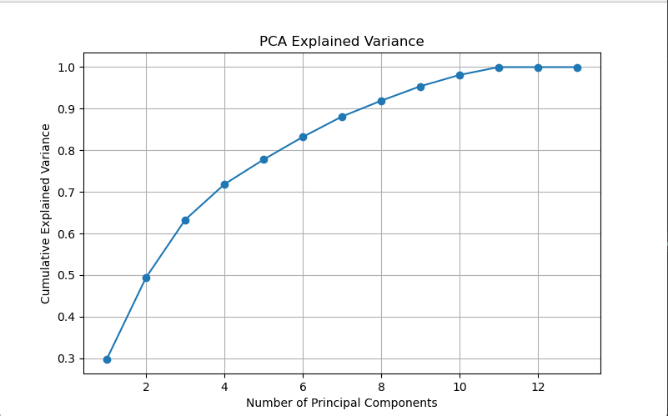

4. Determining the Optimal Number of Clusters
Two evaluation techniques were used to determine the optimal number of clusters:
- Elbow Method
- Silhouette Score Analysis

4.1 Elbow Method
The Elbow Method evaluates different numbers of clusters by measuring Within-Cluster Sum of Squares (WCSS).
WCSS represents the distance between data points and their assigned cluster centre. A lower WCSS indicates more compact clusters.
The number of clusters was tested between 2 and 10.
Result
The Elbow curve indicated that improvements in clustering performance began to reduce after five clusters.

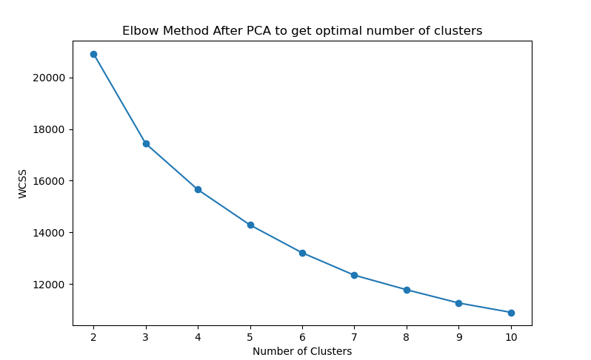
All the clusters were analysed based on the Silhouette Score to confirm the optimal number of clusters.

4.2 Silhouette Score Analysis
The Silhouette Score was calculated to measure how well-separated each cluster was.
The score ranges from -1 to 1:
Score | Interpretation
0.70 - 1.00 | Strong cluster separation
0.50 - 0.70 | Good separation
0.25 - 0.50 | Moderate separation
Below 0.25 | Weak separation
The silhouette scores were calculated for cluster values between 2 and 10.
Result
The highest silhouette score was achieved using five clusters.
Selected Parameter | Result
Optimal Clusters | 5
Evaluation Method | Silhouette Score
Supporting Method | Elbow Method
Although the silhouette score indicated some overlap between customer groups, the identified clusters still provided meaningful customer segmentation insights.
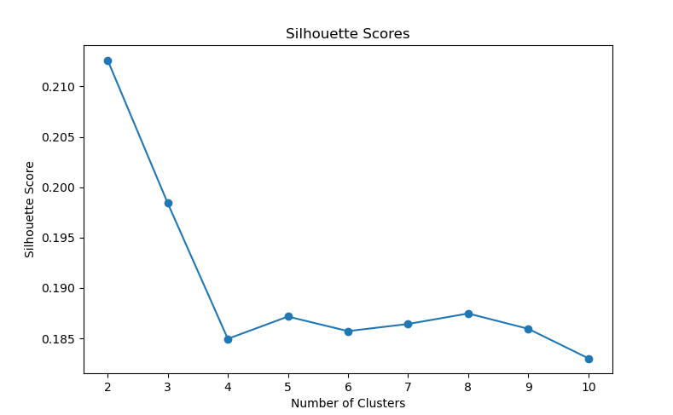

5. K-Means Model Training
The final K-Means model was trained using five clusters.
Model Configuration
Parameter | Value
Algorithm | K-Means
Number of Clusters | 5
Random State | 42
Initialisations | 10
Input Data | PCA-transformed features

6. Cluster Visualisation
After training the K-Means model, each customer was assigned to a cluster.
A two-dimensional PCA projection was created to visualise the customer groups.
Supporting Visualisation:
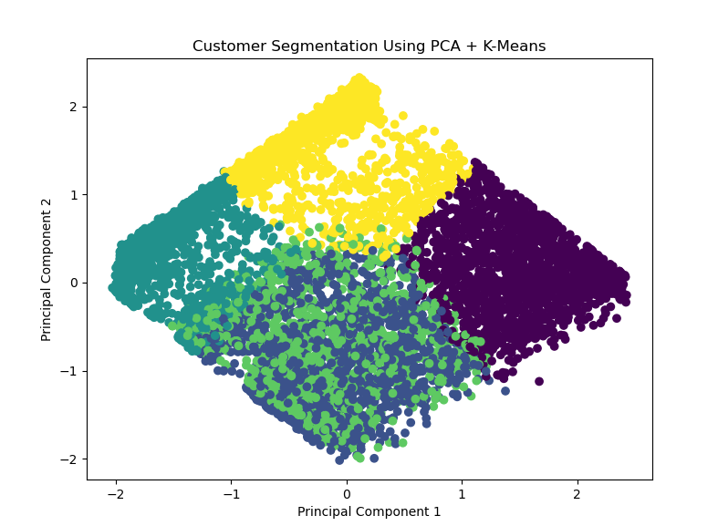
The visualisation displays:
- Customer distribution across clusters.
- Similarity patterns between customers.
- Separation between identified customer groups.

7. Cluster Profiling and Interpretation
After assigning cluster labels, customer characteristics were analysed.
The following metrics were evaluated:
- Number of customers in each cluster.
- Average churn rate.
- Senior citizen proportion.
- Contract type distribution.
- Customer risk level.

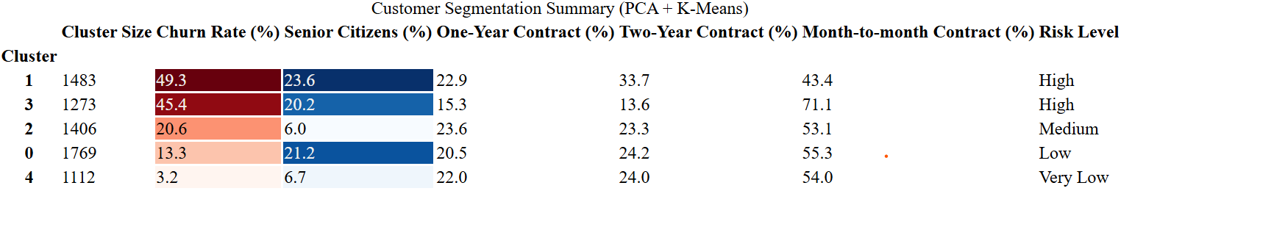

8. Business Insights

Cluster Interpretation
Following PCA dimensionality reduction and K-Means clustering, five distinct customer segments were identified. The clusters were analysed based on customer characteristics, churn behaviour, contract patterns, and demographic attributes to determine their risk profiles.
Cluster | Customer Size | Churn Rate | Key Characteristics | Risk Level | Business Interpretation
Cluster 1 | 1,483 | 49.3% | Highest churn rate, high senior citizen proportion (23.6%), lower adoption of one-year contracts (22.9%) | High Risk | This segment contains customers with the highest likelihood of churn. The combination of shorter commitments and higher churn suggests that these customers may require targeted retention strategies, personalised offers, and improved customer support.
Cluster 3 | 1,273 | 45.4% | High churn rate, moderate senior citizen proportion (20.2%), lowest two-year contract adoption (13.6%) | High Risk | Customers in this segment demonstrate weak long-term commitment. Increasing contract adoption through incentives, loyalty programs, and engagement campaigns may help reduce churn.
Cluster 2 | 1,406 | 20.6% | Moderate churn, low senior citizen proportion (6.0%), balanced contract distribution | Medium Risk | This group represents customers with moderate retention risk. Regular monitoring of satisfaction, service usage, and customer engagement may prevent future churn.
Cluster 0 | 1,769 | 13.3% | Low churn, higher two-year contract adoption (24.2%), stable customer base | Low Risk | These customers demonstrate stronger retention behaviour. Maintaining service quality and providing loyalty rewards can help preserve this relationship.
Cluster 4 | 1,112 | 3.2% | Very low churn, high contract commitment, strong two-year contract adoption (24.0%) | Very Low Risk | This is the most stable customer segment. Customers in this cluster show strong loyalty and represent valuable long-term customers.

Key Insights from PCA + K-Means Clustering
1. High-Risk Customer Segments
Clusters 1 and 3 were identified as the highest-risk customer groups based on their elevated churn rates.
- Cluster 1 has the highest churn rate (49.3%), meaning almost half of customers assigned to this segment have discontinued services.
- Cluster 3 has a similarly high churn rate (45.4%).
Both clusters demonstrate lower adoption of long-term contracts, indicating that customers with weaker contractual commitment may have a higher probability of leaving.
Recommended Business Actions
To reduce churn among these segments, organisations could:
- Encourage migration from month-to-month contracts to one-year or two-year plans through discounts or incentives.
- Provide personalised retention offers based on customer behaviour.
- Investigate potential service issues affecting customer satisfaction.
- Implement proactive communication campaigns before customers decide to leave.

2. Relationship Between Contract Commitment and Customer Retention
The clustering results indicate a noticeable relationship between contract duration and churn behaviour.
Customers in high-risk clusters generally have lower long-term contract adoption, while customers in low-risk clusters demonstrate stronger contract commitment.
Examples:
Cluster | Two-Year Contract Adoption | Churn Rate
Cluster 3 | 13.6% | 45.4%
Cluster 4 | 24.0% | 3.2%
This suggests that customers with longer contractual commitments tend to demonstrate stronger retention behaviour. Contract duration appears to be an important factor associated with customer loyalty.

3. Customer Segmentation by Risk Profile
The clustering model successfully separated customers into meaningful groups based on behavioural and demographic characteristics.
High Risk
│
├── Cluster 1 (49.3% churn)
└── Cluster 3 (45.4% churn)

Medium Risk
│
└── Cluster 2 (20.6% churn)

Low Risk
│
├── Cluster 0 (13.3% churn)
└── Cluster 4 (3.2% churn)

Overall Conclusion
The PCA + K-Means clustering approach successfully identified five customer segments with different churn behaviours and retention characteristics.
Although K-Means clustering does not directly predict churn, analysing churn rates within each cluster revealed clear differences between customer groups. The results demonstrate that churn behaviour is concentrated within specific customer segments rather than evenly distributed across the entire customer population.
Clusters 1 and 3 represent priority segments for churn prevention activities due to their high churn rates and lower contract commitment. In contrast, Clusters 0 and 4 represent loyal customer groups that should be maintained through continued service improvements, loyalty programs, and customer relationship management strategies.
These segmentation insights provide valuable support for targeted retention strategies and allow businesses to allocate resources more effectively toward customers with the greatest risk of churn.



9. Conclusion
The PCA and K-Means clustering approach successfully segmented customers into five distinct groups based on their behavioural characteristics.
The optimal number of clusters was selected using both the Elbow Method and Silhouette Score evaluation. The final clustering model provides valuable insights into customer groups and enables identification of high-risk segments that can be targeted with customer retention strategies.

